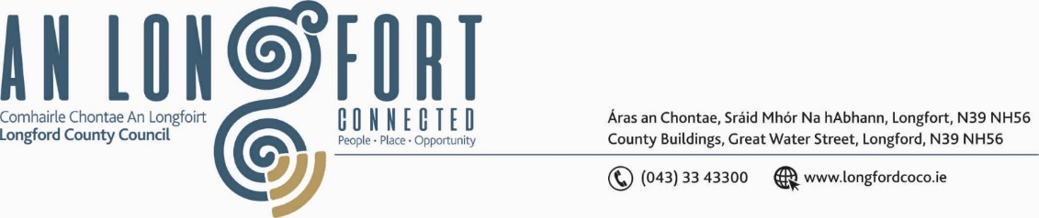

***BALLYMAHON MUNICIPAL DISTRICT***

***Please note meeting will be held in Ballymahon Library and via Microsoft Teams.***

**15thOctober 2021.**

**To: Each Member of Ballymahon Municipal District.**

**Dear Member,**

You are requested to attend a Meeting of Ballymahon Municipal District to be held

**in Ballymahon Library and via Microsoft Teams** on **Thursday, 28th October 2021 at 4pm** to transact business, as set out on the Agenda hereunder.

**Yours sincerely**,

Ann Marie Mc Keon

_______________

**Ann Marie Mc Keon,**

**Meetings Administrator.**

**AGENDA**

Prayer before meeting.

**1.** Consideration of 2022-2024 Multi-Annual Restoration Improvement Programme – to follow.

**2.** Consideration of the 2022 General Municipal Allocation.

**3.** Consideration of applications for funding under the 2021 Community Grant Support

Scheme – to follow.